**Object oriented Programming (OOP)**

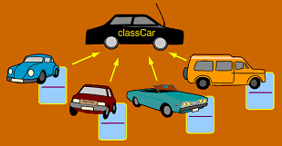

**Class:**

Simply ***Blueprint.***

**Object:**

Instance of that ***Blueprint.***

For making a class you need to think 3 major things –

* Its name (e.g. - car)
* What it is like? (e.g. – color, speed)
* What it does? (e.g. – It can move, It can spin)

Because of these a class is made up with 3 sections –

* Class name
* Attributes
* Methods

**Human Example:**

